**IW Express API Documentation**

Table of Contents

**API #1:**  **Softdata Upload** 3

**API #2:**  **Shipping Label** 4

**API #3:**  **Softdata Upload & Shipping Label** 6

**API #4:** **Consignment Tracking** 9

**Client Status Update Webhook** 10

## **API #1: Softdata Upload**

API URL: http://15.207.62.25:5101/iwexpress/iwe-integration-service/softdata/upload

Request Type: POST

Input Authorization as like below.

Basic $2a$10$qWHNeBhu4FCGoJfuv2XVbO9Yq4QBUwGSvNM0bGpYUVc3iY8jXsJwO

Request Payload

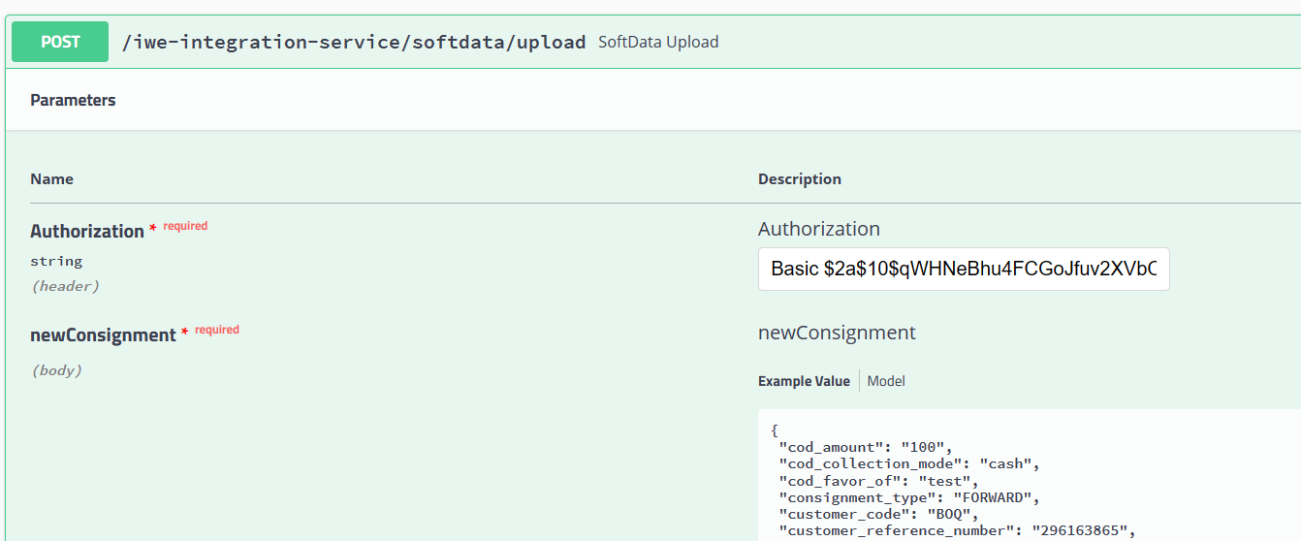

Response with <Consignment Reference Number>

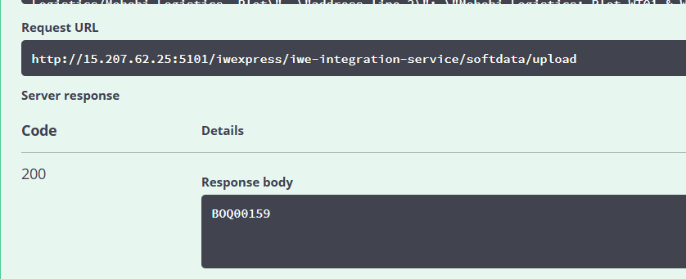

**SAMPLE REQUEST**

{

"cod_amount": "100",

"cod_collection_mode": "cash",

"cod_favor_of": "test",

"consignment_type": "FORWARD",

"customer_code": "BOQ",

"customer_reference_number": "296163865",

"declared_value": 100,

"description": "Gift",

"destination_details": {

"address_line_1": "house 61 Block 5, street 517",

"address_line_2": "LF Logistics/Mohebi Logistics, Plot",

"alternate_phone": "string",

"city": "Kuwait",

"country": "Kuwait",

"name": "محمد الصميم",

"phone": "string",

"pincode": "91710",

"state": "string"

},

"dimension_unit": "CM",

"height": "5",

"is_risk_surcharge_applicable": true,

"length": "10",

"load_type": "DOCUMENT",

"notes": "test",

"num_pieces": 10,

"origin_details": {

"address_line_1": "LF Logistics/Mohebi Logistics, Plot",

"address_line_2": "Mohebi Logistics; Plot WT01 & WT04",

"alternate_phone": "",

"city": "Dubai",

"country": "UAE",

"name": " مجموعة الكوخ",

"phone": "97101606811863",

"pincode": "8005",

"state": "DUBAI"

},

"pieces_detail": [

{

"declared_value": 100,

"description": "Gift",

"height": 100,

"length": 500,

"weight": 1.2,

"width": 200

}

],

"service_type_id": "PREMIUM",

"weight": 1.2,

"weight_unit": "KG",

"width": "200"

}

## **API #2: Shipping Label**

API URL:

[http://15.207.62.25:5101/iwexpress/iwe-integration-service/{referenceNumber}/shippingLabel](http://15.207.62.25:5101/iwexpress/iwe-integration-service/%7breferenceNumber%7d/shippingLabel)

Sample Request:

http://15.207.62.25:5101/iwexpress/iwe-integration-service/BOQ00159/shippingLabel

Request Type: POST

Input Authorization as like below.

Basic $2a$10$qWHNeBhu4FCGoJfuv2XVbO9Yq4QBUwGSvNM0bGpYUVc3iY8jXsJwO

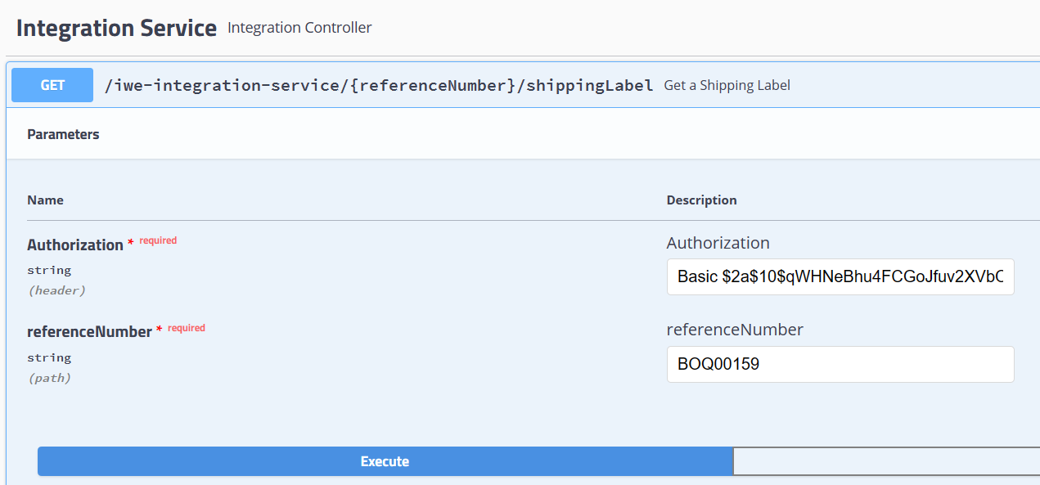

Response: <pdf file>

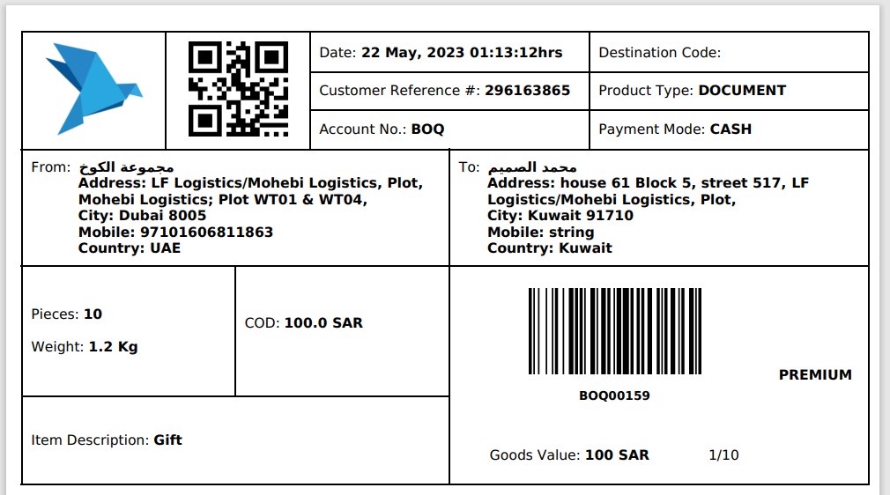

## **API #3: Softdata Upload & Shipping Label**

API URL: <http://15.207.62.25:5101/iwexpress/iwe-integration-service/softdata/upload>/v2

Request Type: POST

Input Authorization as like below.

Basic $2a$10$qWHNeBhu4FCGoJfuv2XVbO9Yq4QBUwGSvNM0bGpYUVc3iY8jXsJwO

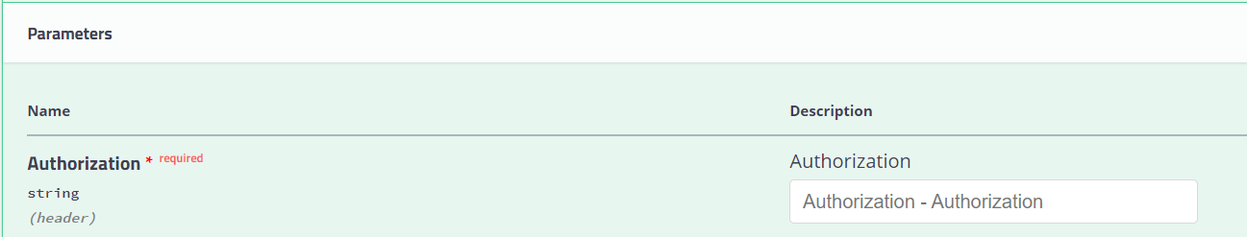

Order Details as like below structure (JSON Provided)

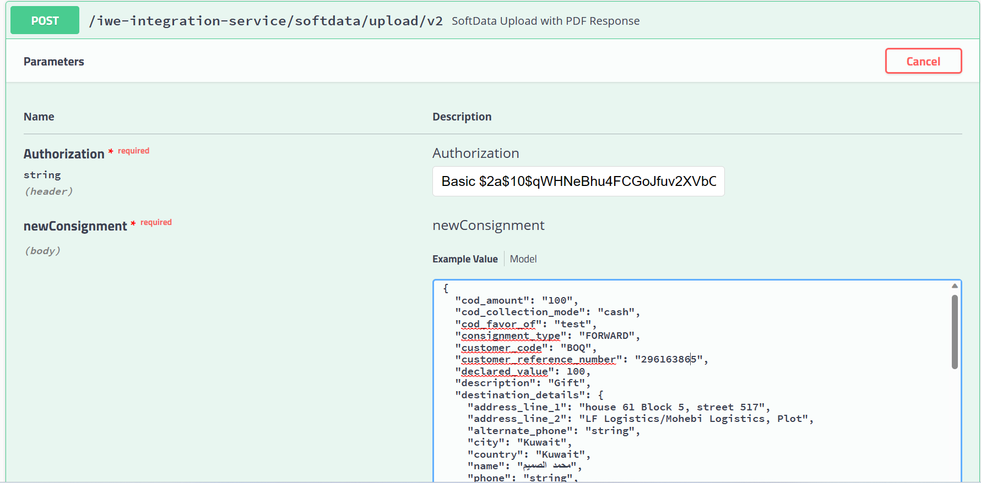



Request JSON

{

"cod_amount": "string",

"cod_collection_mode": "string",

"cod_favor_of": "string",

"consignment_type": "string",

"customer_code": "BOQ",

"customer_reference_number": " 296163865",

"declared_value": 0,

"description": "string",

"destination_details": {

"address_line_1": "string",

"address_line_2": "string",

"alternate_phone": "string",

"city": "string",

"country": "string",

"name": "string",

"phone": "string",

"pincode": "string",

"state": "string"

},

"dimension_unit": "string",

"height": "string",

"is_risk_surcharge_applicable": true,

"length": "string",

"load_type": "string",

"notes": "string",

"num_pieces": 0,

"origin_details": {

"address_line_1": "string",

"address_line_2": "string",

"alternate_phone": "string",

"city": "string",

"country": "string",

"name": "string",

"phone": "string",

"pincode": "string",

"state": "string"

},

"pieces_detail": [

{

"declared_value": 0,

"description": "string",

"height": 0,

"length": 0,

"weight": 0,

"width": 0

}

],

"service_type_id": "string",

"weight": 0,

"weight_unit": "string",

"width": "string"

}

**SAMPLE REQUEST**

{

"cod_amount": "100",

"cod_collection_mode": "cash",

"cod_favor_of": "test",

"consignment_type": "FORWARD",

"customer_code": "BOQ",

"customer_reference_number": "296163865",

"declared_value": 100,

"description": "Gift",

"destination_details": {

"address_line_1": "house 61 Block 5, street 517",

"address_line_2": "LF Logistics/Mohebi Logistics, Plot",

"alternate_phone": "string",

"city": "Kuwait",

"country": "Kuwait",

"name": "محمد الصميم",

"phone": "string",

"pincode": "91710",

"state": "string"

},

"dimension_unit": "CM",

"height": "5",

"is_risk_surcharge_applicable": true,

"length": "10",

"load_type": "DOCUMENT",

"notes": "test",

"num_pieces": 10,

"origin_details": {

"address_line_1": "LF Logistics/Mohebi Logistics, Plot",

"address_line_2": "Mohebi Logistics; Plot WT01 & WT04",

"alternate_phone": "",

"city": "Dubai",

"country": "UAE",

"name": " مجموعة الكوخ",

"phone": "97101606811863",

"pincode": "8005",

"state": "DUBAI"

},

"pieces_detail": [

{

"declared_value": 100,

"description": "Gift",

"height": 100,

"length": 500,

"weight": 1.2,

"width": 200

}

],

"service_type_id": "PREMIUM",

"weight": 1.2,

"weight_unit": "KG",

"width": "200"

}

Response JSON: [PDF Stream response]

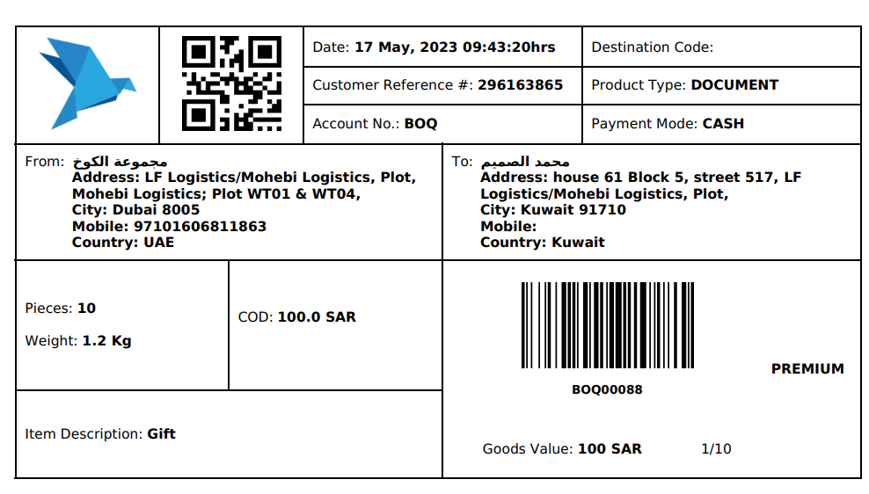



## **API #4: Consignment Tracking**

API URL:

http://15.207.62.25:5101/iwexpress/iwe-integration-service/tracking/{referenceNumber}/shipment

Request Type : GET

Authorization:

Basic $2a$10$qWHNeBhu4FCGoJfuv2XVbO9Yq4QBUwGSvNM0bGpYUVc3iY8jXsJwO

referenceNumber:

[consignment reference number]

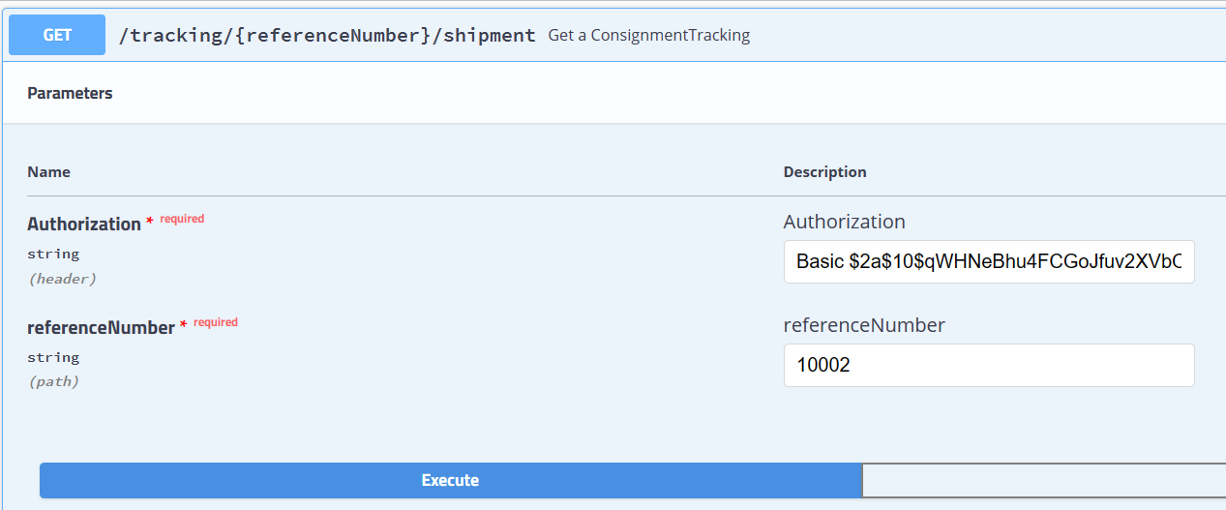

Sample Request:

<http://15.207.62.25:5101/iwexpress/tracking/10002/shipment>

Response JSON: [Consignment Tracking details]

## **Client Status Update Webhook**

Following are the list of events (with description) supported which is provided in the key type as seen in the payload.

1. **accept** - When the consignment is out for delivery
2. **added_to_bag** - When the consignment is added to a bag in a trip
3. **assigned_for_delivery** - When an consignment is assigned to any rider for delivery
4. **assigned_to_hub** - When task is assigned to rider for delivery
5. **attempted** - When a consignment is undelivered
6. **bag_received** - When bag is unloaded from the trip
7. **cancelled** - When a consignment is cancelled
8. **consignment_verification** - When consignment Verification is done
9. **customs_clearance_completed** - When the consignment is cleared from customs
10. **delay_at_airport** - When the consignment is at airport and not processed due to some reasons
11. **delivered** - When a consignment is delivered
12. **delivery_pod** - When the 3PL send s POD separately post the delivered event (Select this event is you ar using delivered event)
13. **deps_exception** - When the consignment is received as Damaged, Excess, Shortage or Pilferage
14. **exception** - When a event is received that does not belong to other events in the list
15. **handed_in_customs_clearance** - When the consignment is handed to the customs at airport
16. **handover_courier_partner** - When the consignment is handed over to the 3PL
17. **inscan_at_hub** - When a consignment is inscanned at any hub
18. **intransittohub** - When a consignment is part of any mid mile hub and the mid mile trip is ongoing
19. **lost** - When a consignment is lost
20. **not_picked_up** - When the consignment is not picked up
21. **on_hold** - When consignment is put on hold for some reasons
22. **out_for_pickup** - When the delivery executive is out for pickup
23. **out_for_store_pickup** - When the delivery executive is out for pickup (PUDO Flow only)
24. **outscan_at_hub** - When a consignment is marked as outscan from a hub
25. **pickup_awaited** - When the delivery executive is yet to be assigned for pickup
26. **pickup_completed** - When the pickup is completed by the delivery executive
27. **pickup_scheduled** - When the pickup has been scheduled for a consignment
28. **reachedathub** - When the consignment reached the destination hub (generally the last mile hub)
29. **release_on_hold** - When a consignment is released from hold
30. **reschedule** - When the consignment pickup or delivery is rescheduled
31. **returned_at_hub** - When the consignment is received at hub post a delivery attempt
32. **revert_from_delivered** - When a consignment is revoked from delivery for exceptional reasons (Aplicable from CRM)
33. **revoke_rto** - When RTO is revoked for exceptional reasons (Applicable from CRM)
34. **rto** - When the consignment is marked as RTO
35. **rto_attempted** - When the consignment is undelivered in a RTO journey
36. **rto_delivered** - When the consignment is delivered in a RTO journey
37. **rto_in_transit** - When the consignment is in transit in a RTO journey
38. **rto_initiated** - When the consignment is marked as RTO (this is a preferred over the event rto)
39. **rto_inscan_at_hub** - When the consignment is inscanned at hub in a RTO journey
40. **rto_outfordelivery** - When the consignment is out for delivery in a RTO Journey
41. **seized** - When the consignment is seized by an external party before being delivered
42. **shelved** - When the consignment is shelved for some reasons
43. **softdata_upload** - When consignment is created in Shipsy system
44. **vehicle_arrived** - When the vehicle has arrived to a different hub in a middle mile trip